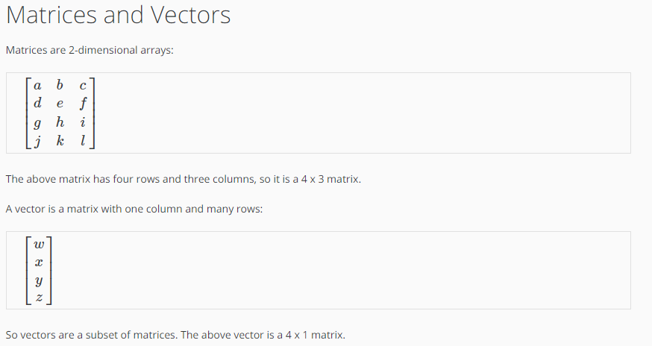
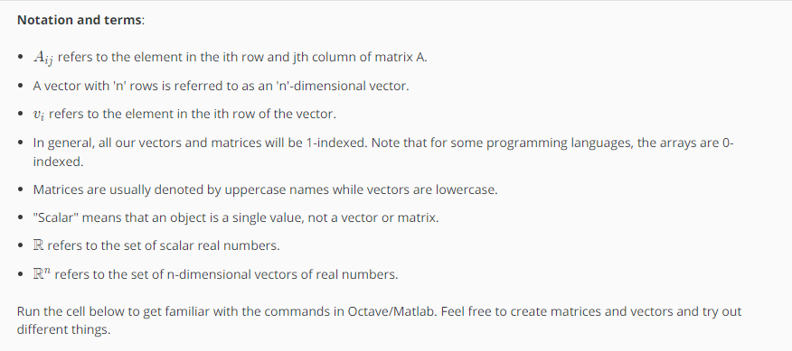
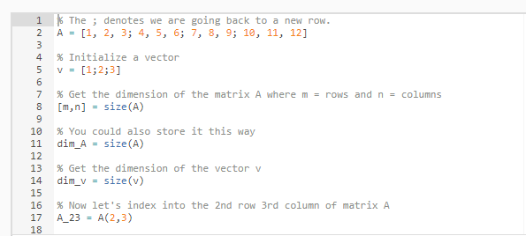

CODE:
% The ; denotes we are going back to a new row.
A = [1, 2, 3; 4, 5, 6; 7, 8, 9; 10, 11, 12]

% Initialize a vector
v = [1;2;3]

% Get the dimension of the matrix A where m = rows and n = columns
[m,n] = size(A)

% You could also store it this way
dim_A = size(A)

% Get the dimension of the vector v
dim_v = size(v)

% Now let's index into the 2nd row 3rd column of matrix A
A_23 = A(2,3)

OUTPUT:
